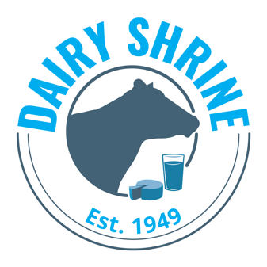

Klussendorf and McKown Scholarship Applications

The Klussendorf and McKown scholarships were made available as a result of a gift from the late Klussendorf member Chris Kampf, who won the Klussendorf award in 1956. Monies raised by the McKown family and friends of the late “Whitey” McKown, named an honorary Klussendorf member in 1997, make up the funds available for the McKown/Klussendorf Scholarship. There have been other substantial monies raised by the Klussendorf members to allow the association to expand the scholarship program. The Arthur B. Klussendorf Memorial Association honors those who most nearly exemplify the character and ethics of this late, legendary showman and dairy cattle fitter.

The Klussendorf Association will award three $1,500 scholarships, and the McKown/Klussendorf Fund will offer four $1,500 scholarships this year. To be eligible, students must be in their first, second, or third year at a 2-year or 4-year college or university in the United States or Canada majoring in dairy science, animal science, agri-business, or other related majors that will develop the skills needed to pursue a career in the dairy industry. Youth affiliated with all dairy breeds are encouraged to apply for these scholarships; however, the McKown scholarships will give preference to youth from predominately Holstein backgrounds. Past, present, or potential members of dairy cattle judging teams will receive special consideration. Applicants need to show leadership, participation in extracurricular activities, and a special interest and ability in showing dairy cattle in their best natural form.

Scholarship recipients will be recognized at the Dairy Shrine Awards Banquet.

Application/Transcripts are accepted from March 1 until April 15, midnight, CST.

Instructions for applying:

- Download this application and type in your responses. Save the file as KLU.Last Name.First Name.doc. Email to info@dairyshrine.org. If you have problems, please e-mail NDS.

- Mail an official transcript showing all college courses and grades to be viewed only by the Dairy Shrine Executive Director.

Klussendorf / McKown Scholarship – page 2

I. Personal Data
Last Name First Name Middle Initial
Applicant

College/University

Year in School Grade Point Average

Complete Home Address

( ) ( )
Home Phone Number Cell Phone Number

Email Address

II. In 200 words or less, describe your dairy cattle experiences (home dairy and/or other dairies):

III. Provide a “Top 10 List” of dairy related participation and other student-related activities. Include 4-H, FFA, or breed association experiences in dairy cattle judging, showing, and other activities. (Do not to exceed 200 words for the entire response to this question.)

NDS/Klussendorf Scholarship – page 3

IV. Provide a “Top 10 List” of leadership roles (not to exceed 200 words for the entire response to this question).

V. In 200 words or less, please answer the following question: Why do you want to be part of the U.S. or Canadian dairy industry’s future? What role do you wish to pursue? How are you preparing yourself for this role?

_________________________________________________________________________________________
Dairy Shrine Board of Directors: Students who are members of Dairy Shrine are eligible to serve on the Board of Directors for Dairy Shrine. A Board term is for 3 years and terms begin at the October Annual Meeting. Please check below if you would be interested in serving a 3-year term on the Dairy Shrine Board of Directors if recommended by the Dairy Shrine Nominating Committee and elected to the Board of Directors at the Dairy Shrine Annual Meeting in October.
____ Yes, I would like the Dairy Shrine Nominating Committee to consider me as a candidate for the Dairy Shrine Board of Directors.

